केंद्रीय विद्यालय संगठन
केंद्रीय विद्यालय आर्मी एरिया, पुणे-४०, संभाग-मुंबई
KENDRIYA VIDYALAYA ARMY AREA, PUNE-40 , REGION-MUMBAI

REGISTRATION FORM FOR NON-KV STUDENTS FOR ADMISSION TO CLASS XI (2023-24)
Reg. No Date of Reg.

STREAM CHOICE:
Paste your Latest Photograph
- SCIENCE

- COMMERCE

- HUMANITIES

- Name of Applicant:
- School last Attended:

- (a) Father’s Name:
  - Occupation:
  - Basic Pay :
Mother’s Name Occupation: Basic Pay:

  - Service Category of Parent as per KVS Admission guidelines

- Residential Address:

- Phone /Mobile No Email id

- Category of Applicant (Specify Gen./ SC/ST/OBC(NCL)):

(If SC/ST/OBC (NCL) attach self-attested photocopy of certificates)

- Result of class X (supported by photo copy of mark sheet) CBSE Roll No.

Subject | Marks | Subject | Marks
Hindi |  | Mathematics Standard
Sanskrit |  | Mathematics Basic
English |  | Science
Social Science |  | Total Marks with % | /500 | %
- Aggregate Marks in Science & Math

- Subject Opted Core Subject (1) English

Elective Subject (2) (3)

(4) (5)

- Whether participated in SGFI/KVS National /Regional Sports Meet/Scout/Guide/NCC (if yes, please attach attested photo copies of certificate and give details). Specify the level also

(All taken together Aggregate Marks will not be exceeded by 6%)
We hereby declare that the above information furnished is true to the best of our knowledge.

Date: Signature of Student ________________Parent‘s Signature_____________________

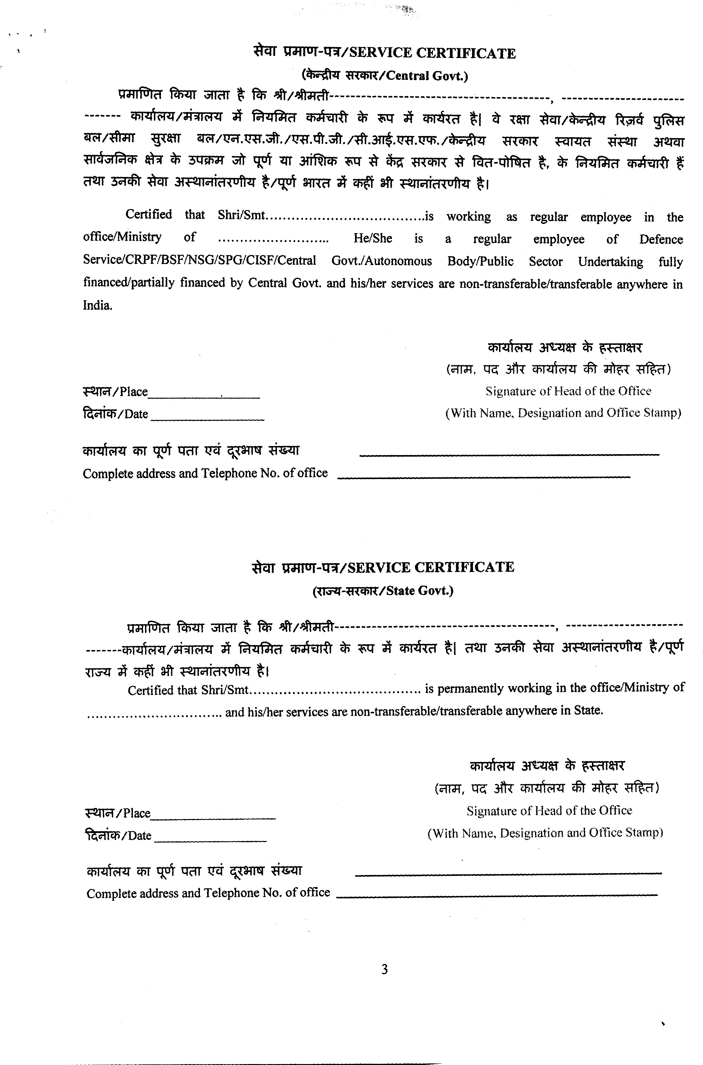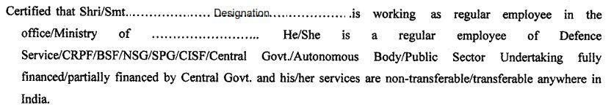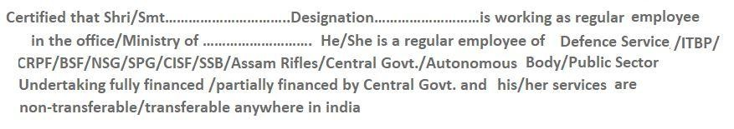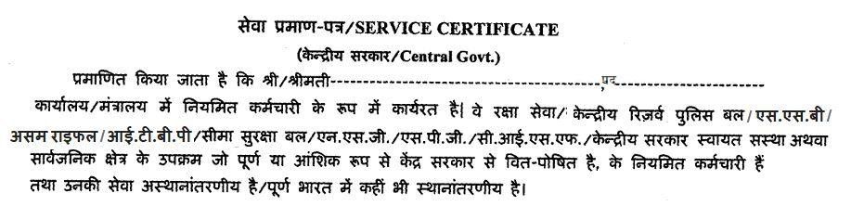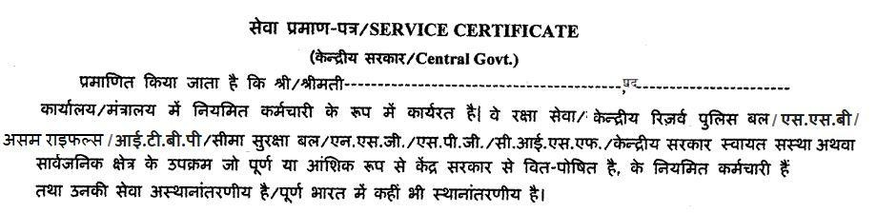
Designation

पद
Designation

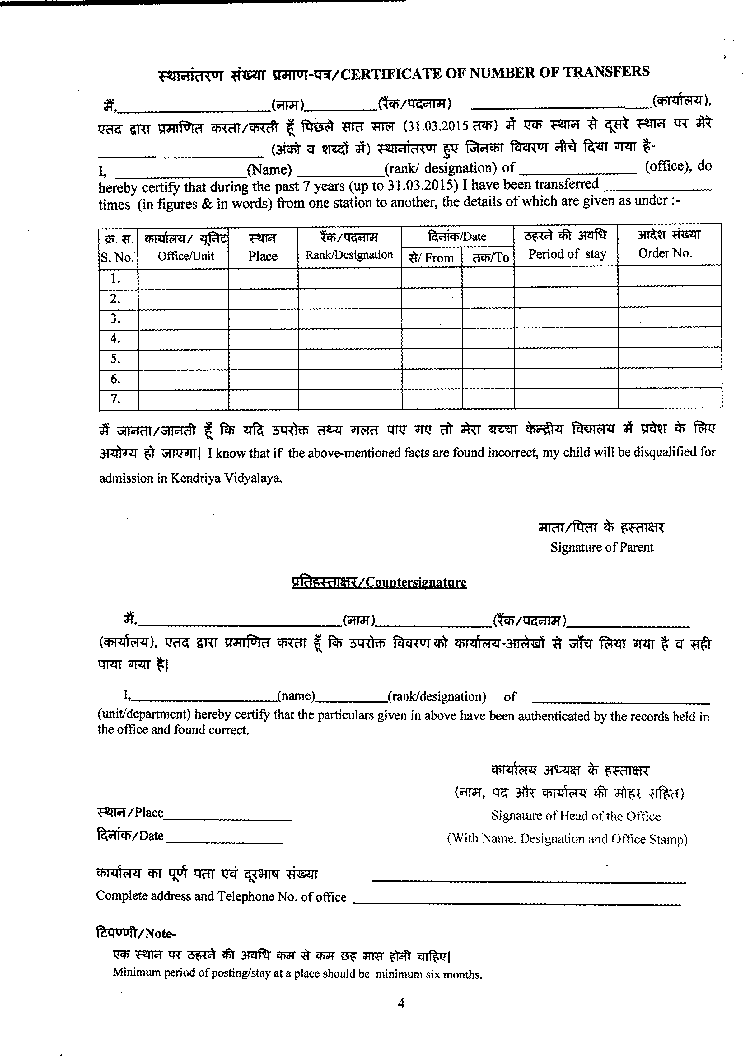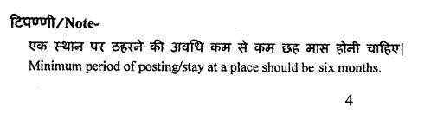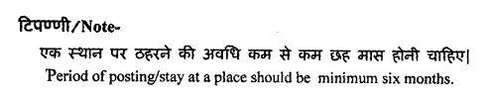
20

20

